Vpc 02 task
- Create one VPC, with 1 public subnet and 1 private subnet.
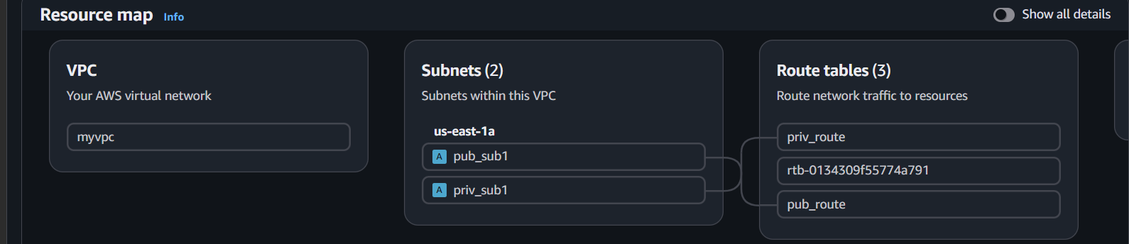
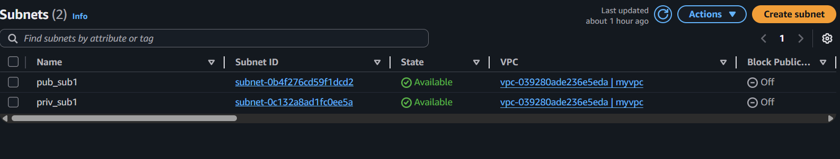
- Enable VPC peering for cross-region.
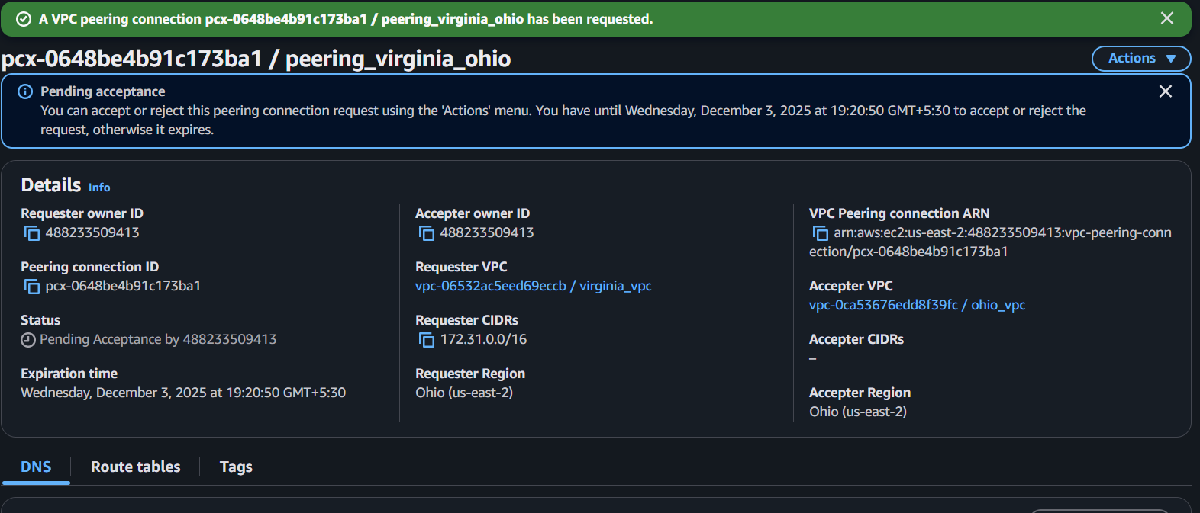
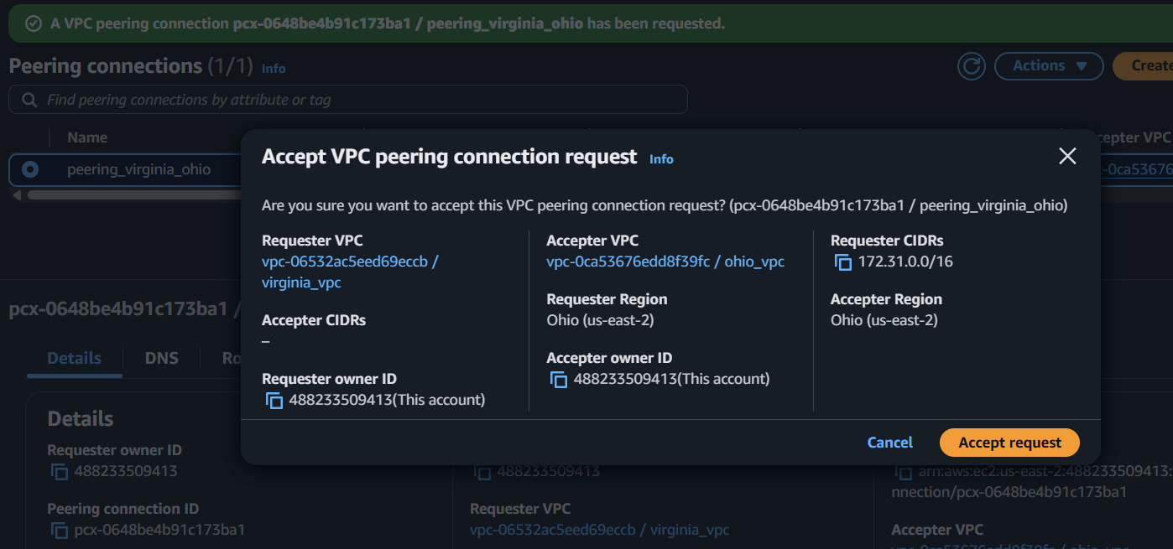
Accept the peering
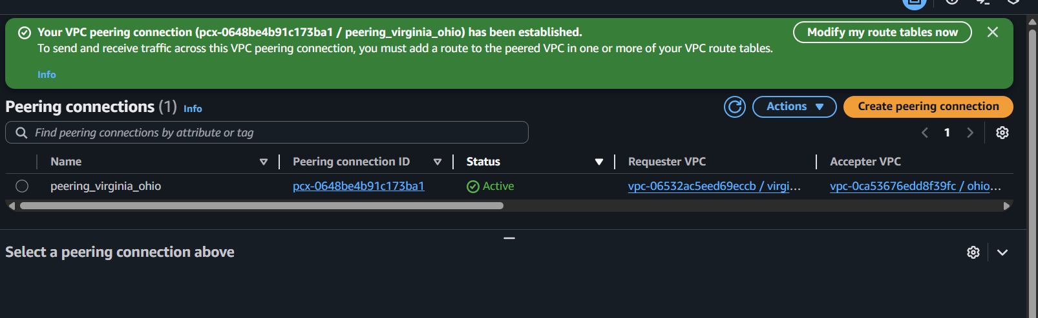Copy cidr of ohio and paste in pub myvpc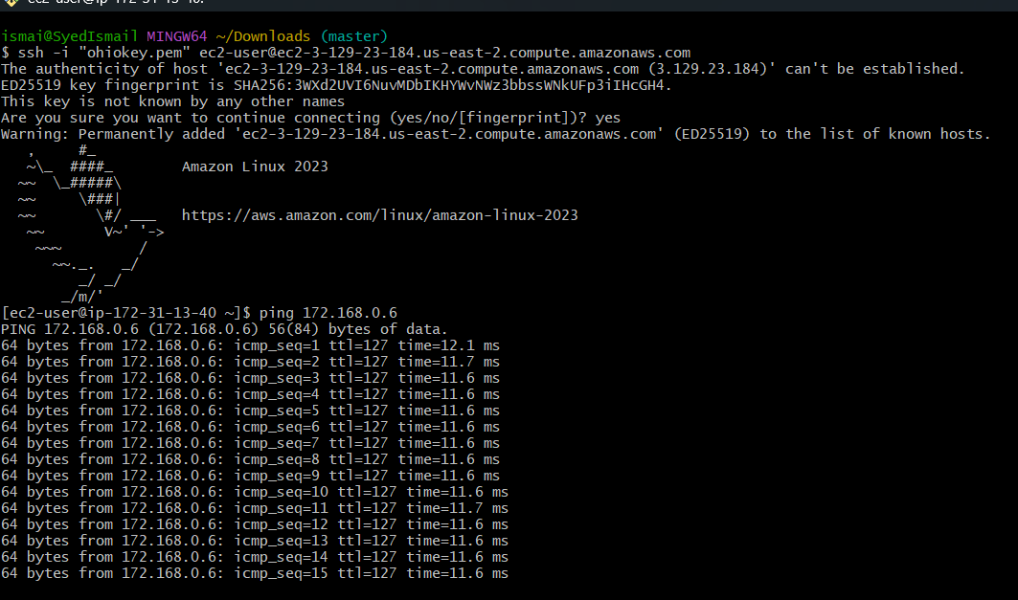

- Enable VPC peering for cross-account (you can collaborate with your friend to do this
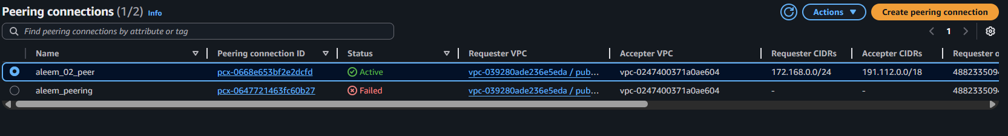
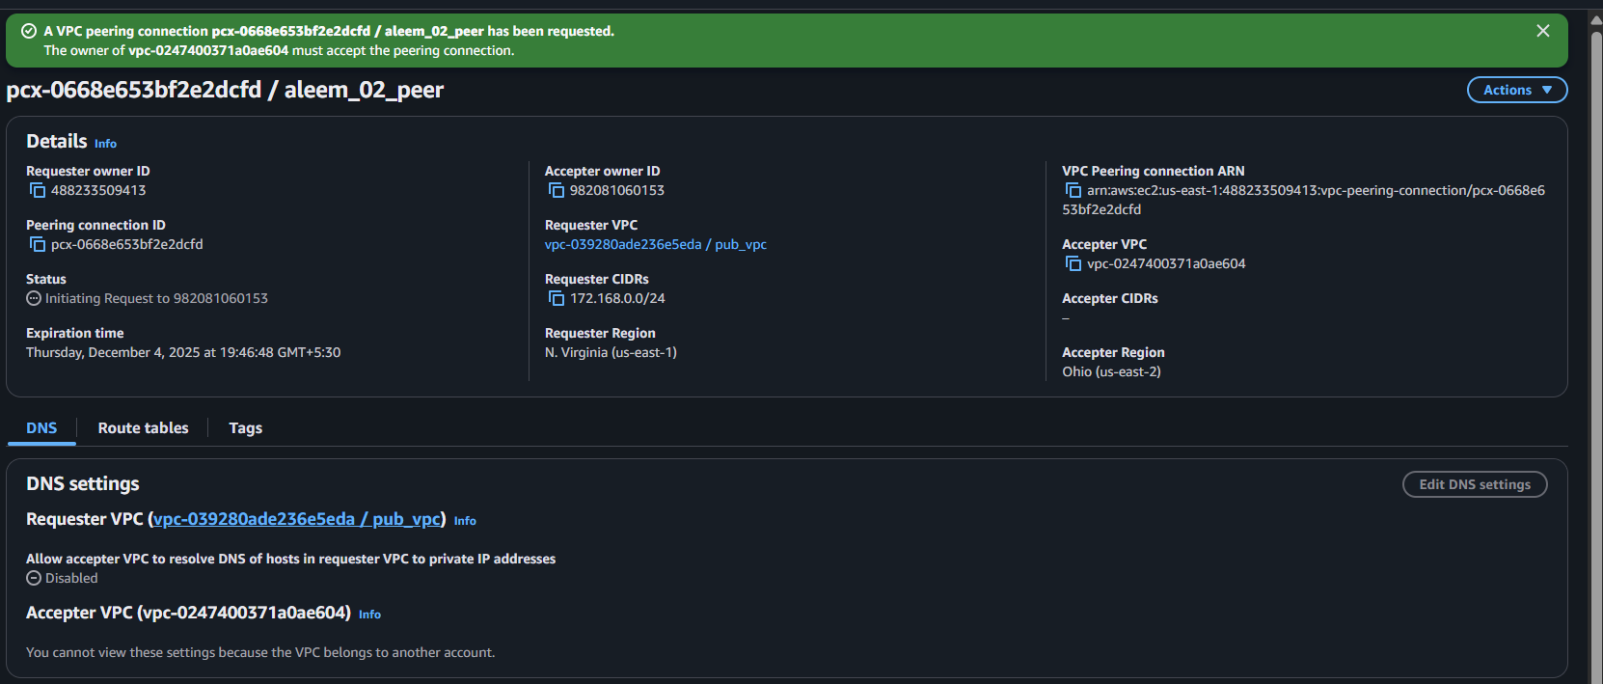
- Set up a VPC Transit Gateway.
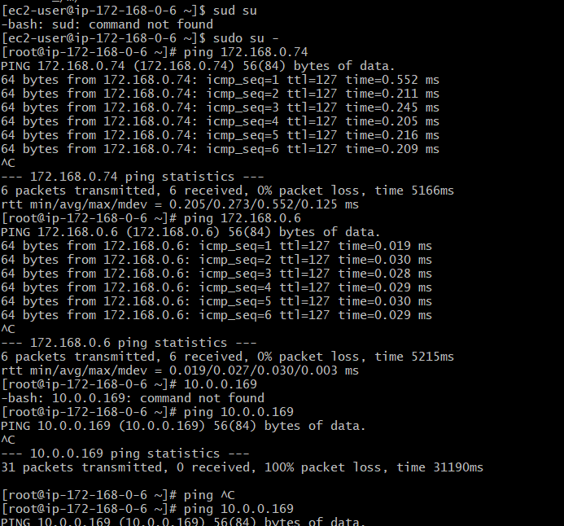

- Set up a VPC Endpoint.
Public server
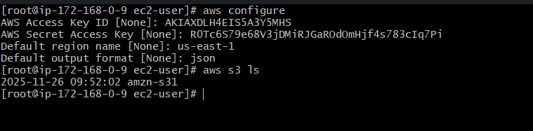
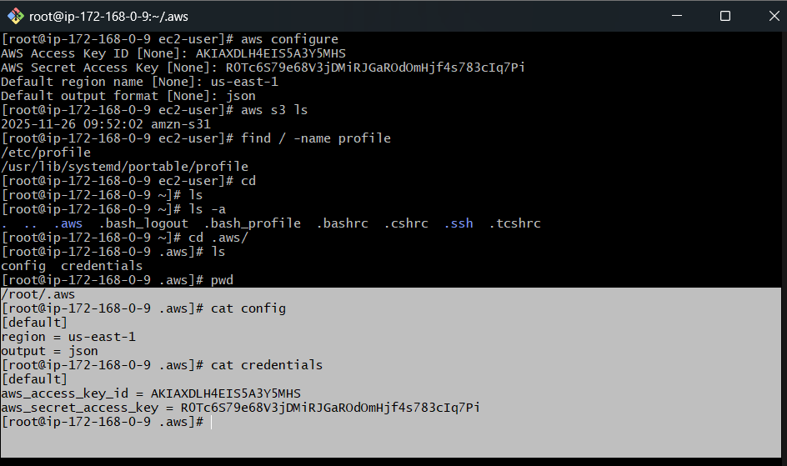

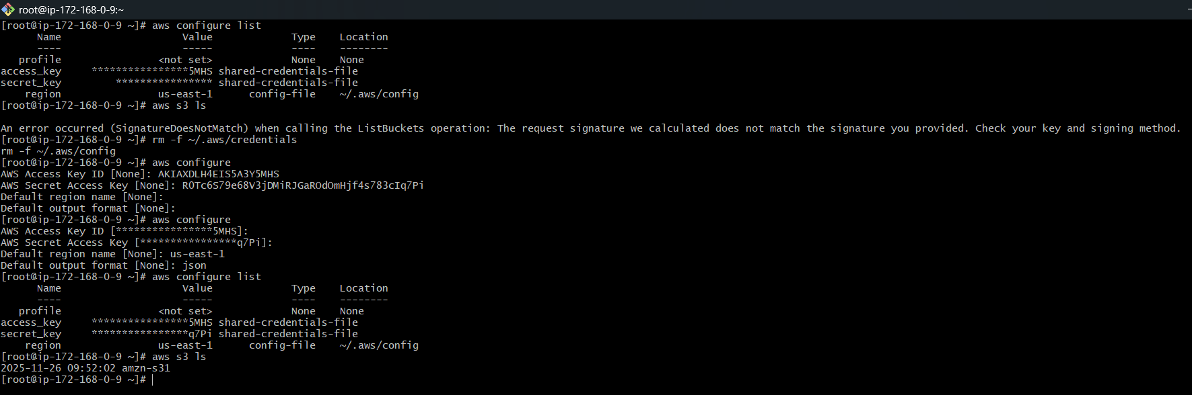

Private server
